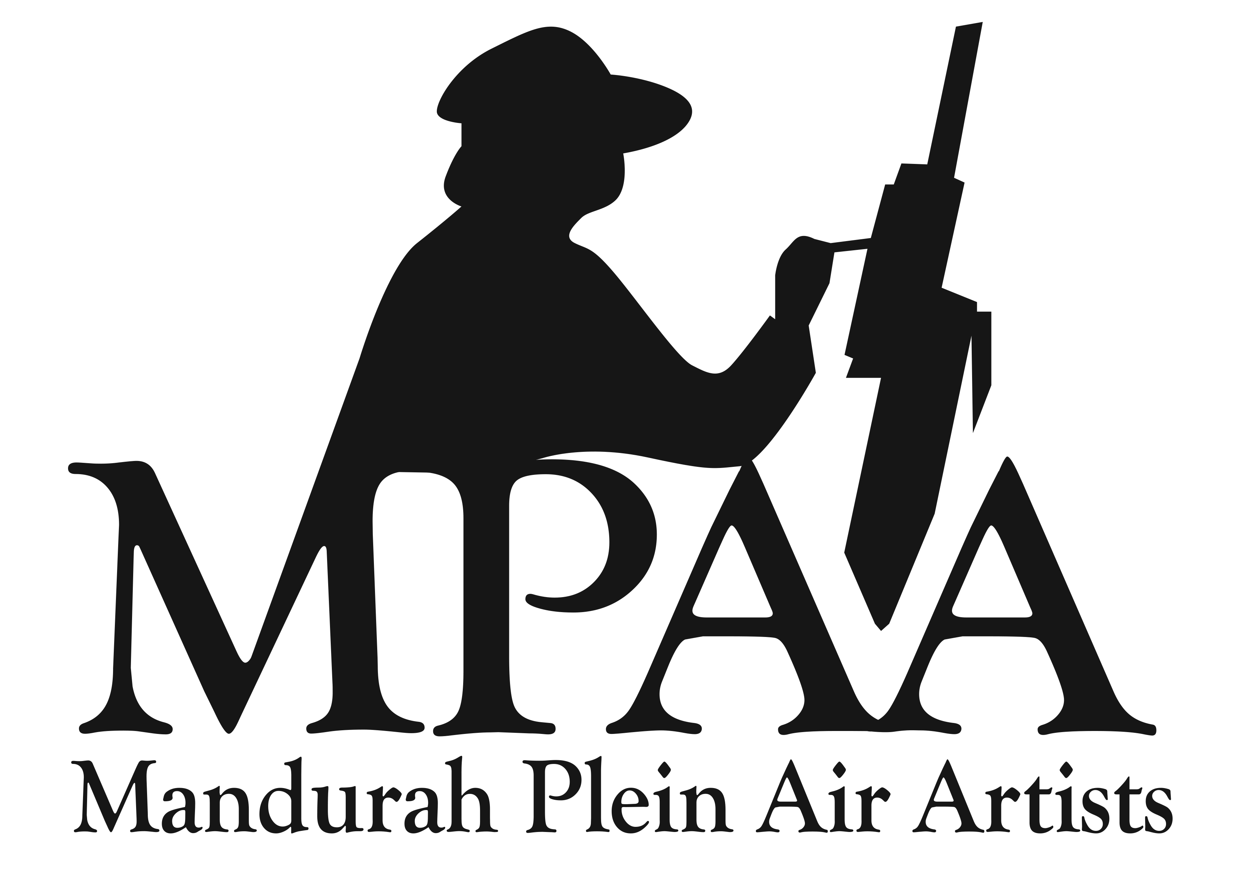
MANDURAH PLEIN AIR ARTISTS SKILLS RECORD

Member Skills & Contributions Survey
Thank you for being part of our painting group! Please tick the areas you have skills or interest in, and add notes where relevant.

Contact Details
Name: __________________________________________________________ Phone: _________________________
Email: ____________________________________________________________ Suburb: _______________________

Skills & Experience
Skill Area | Specific Apps/Tools | Tick | Notes
Social Media | Facebook, Instagram | ☐
Graphic Design | Canva, Photoshop, Other | ☐
Secretarial & Computer Skills | Email, Gmail, Mailchimp, Word, Excel, Google Drive | ☐
Finance / Bookkeeping | Xero, Excel, Other | ☐
Website / Blog | WordPress, Wix (Other) | ☐
Photography / Video | Smartphone, DSLR, YouTube, Other | ☐
Art Handling / Hanging | — | ☐
Fundraising / Grant Writing | — | ☐
Event Planning / Coordination | — | ☐
Volunteer Coordination | — | ☐
Exhibition Setup / Curation | — | ☐
Technical / IT Support | — | ☐
Transport / Logistics | — | ☐
Other |  | ☐

Availability & Interest
☐ One-off tasks ☐ Project-based roles
☐ Ongoing volunteer roles ☐ Committee positions

Additional Notes
___________________________________________________________________________________________________
___________________________________________________________________________________________________
___________________________________________________________________________________________________

